2023-2026
The Ripple Project
198 Restalrig Road South
Edinburgh
EH7 6DZ

Co Ltd By Guarantee No 214364 Scottish Charity No SC 024973
Our Strategic Plan

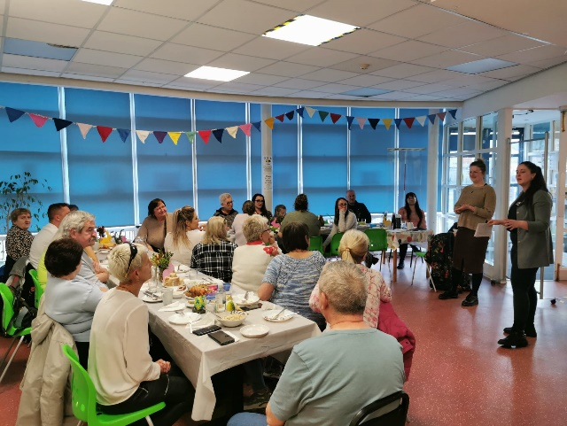
Introduction

We are a grassroots organisation that exists to help the people of Lochend Restalrig and Craigentinny help themselves. Founded in 1996, The Ripple’s roots go back many centuries to the work carried out by St Margaret’s Parish Church as they walked alongside the most vulnerable citizens of Edinburgh.
The Ripple has evolved into a member led organisation operating from a community centre in the heart of our community. As Director of the Ripple, I am proud to share this summary of our strategic plan for 2023 and the coming years.
The Ripple is a community organisation led by, working with and in service to its local people. Without our volunteers and the relationship we have with local people, we would not be the organisation that we are. We seek to listen, understand and react to local needs and aspirations to make life better for everyone.
With a small but committed staff team we are able to provide a space that brings people together on a daily basis to eat, share, learn and grow. We provide safe spaces for older people and young people to be themselves, make friends and take care of themselves.
I look forward to the coming years at the Ripple, working side by side with local people to deliver the changes needed for people to live good lives and thrive in their own community.
Rachel Green
Director

As a local resident I have seen the Ripple become a central feature in our community for over 20 years. I am delighted to see our new strategic plan taking us into the future that sets out how we will continue to achieve our purpose, mission and values.
Jackie Milne
Chair

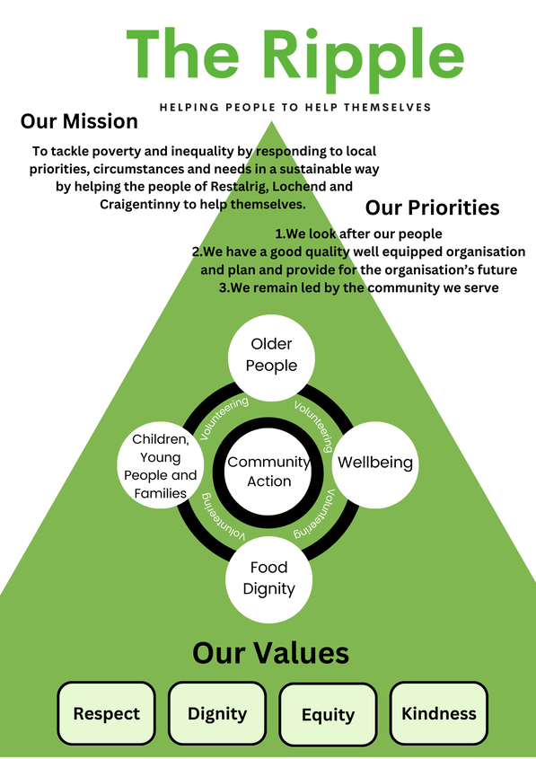
Our Mission
To tackle poverty and inequality by responding to local priorities, circumstances and needs in a sustainable way by helping the people of Restalrig, Lochend and Craigentinny to help themselves.

Our Priorities 2023-2026
- We look after our people
- We have a good quality well equipped organisation and plan and provide for the organisations’ future
- We remain led by the community we serve

What we believe in
- collective action
- social justice and making a positive difference to people’s lives
- taking a holistic approach to people’s needs
- empowering people and making voices heard
- building social capital and reinvesting financial surpluses for community need.

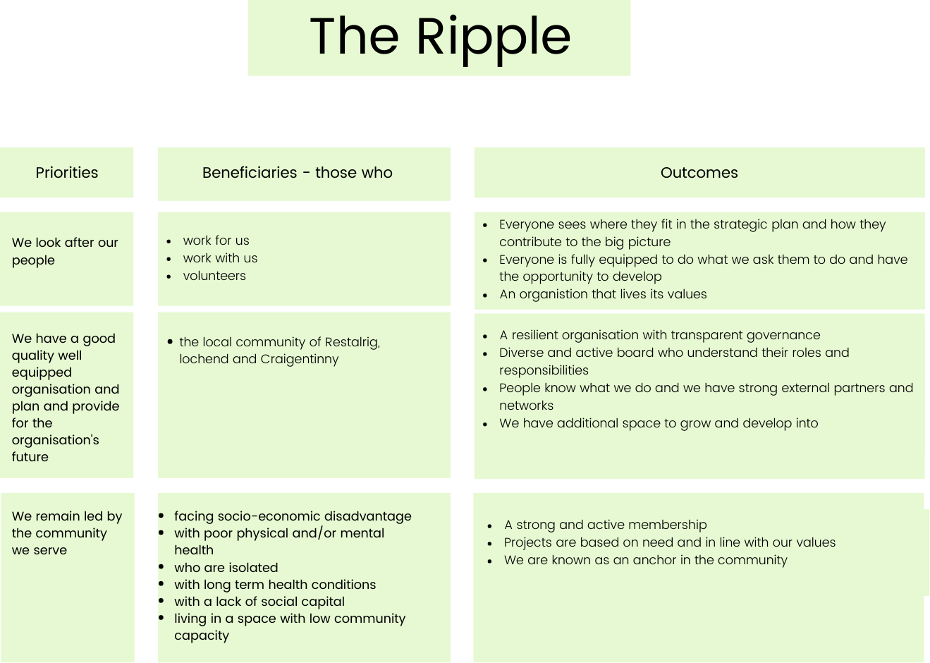
The Ripple’s work
Older people
The Ripple provides a wide range of services for older people. We aim to maintain and improve quality of life and help older people remain independent and active within their local community for as long as possible. We do this through
- Increasing social connections and promoting wellbeing
- Improving physical health
- Learning new skills
- Supporting older people to be in control of their own lives and
- Offering opportunities to take part in cultural and recreational activities

Wellbeing
The Ripple Project provides opportunities for local people to maximise their wellbeing. Wellbeing relates to both our physical, mental and emotional health. We work with people to learn how to gain and maintain positive wellbeing to become individuals who are confident, who contribute, who are kind and responsible, healthy and positive, and we can experience dignity, autonomy, community, choice and inclusion. We do this through
- Group work
- Getting out into nature
- Mindfulness sessions
- Outdoor swimming
- Yoga

Food Dignity
The Ripple Project provides services that promote access to food in a dignified way where everyone is food secure, with access to adequate, nutritious and culturally appropriate food. We do this through

- Community café
- Fortnightly pantry
- Weekly fruit and vegetables
- Cooking courses
- Healthy eating courses

Children and Families
The Ripple offers local children & young people aged 6-18yrs a varied programme of play, activities and educational opportunities designed to encourage, develop & reinforce their skills and self image in a safe and supportive environment. We take a family centred approach to our youth work that includes providing assistance with challenges our families are facing. We do this through
- Boys and Girl’s single gender groups
- Weekly drop in’s
- Sports Clubs
- Art Clubs
- Holiday Programmes

Community Action
The Ripple works with local people to increase the understanding, engagement and empowerment of our community in areas that affect their everyday life. We do this through
- Building community and social capacity – helping the community to share knowledge, skills and ideas.
- Community resilience – helping the community to support itself.
- Prevention – a focus on early access to services or support, engagement in design, cross-sector collaboration and partnerships.
- Maintaining and creating wealth –helping people into employment, maximising their income and developing community enterprises.

Volunteering
Volunteers are engaged in every aspect of the Ripple. Direct service volunteers support the community pantry, the café and our community transport. Group volunteers help with art, craft and computer projects. Community volunteers run local democracy projects and community consultation events. Every service and project we run is an opportunity for volunteers to get involved and learn new skills.
- We are grateful to our volunteers and recognise the difference their efforts make for our work and our community.
- We were founded through the efforts of dedicated volunteers, and volunteers continue to play a vital role working alongside staff members to jointly reach our goals.
- Our volunteers are our allies. They believe in, support, and want to be a part of our mission, our values, our history, our culture, and our fight for social justice.

